EXERCISE-3
Assertions in Junit
Scenario: You need to use different assertions in JUnit to validate your test results.
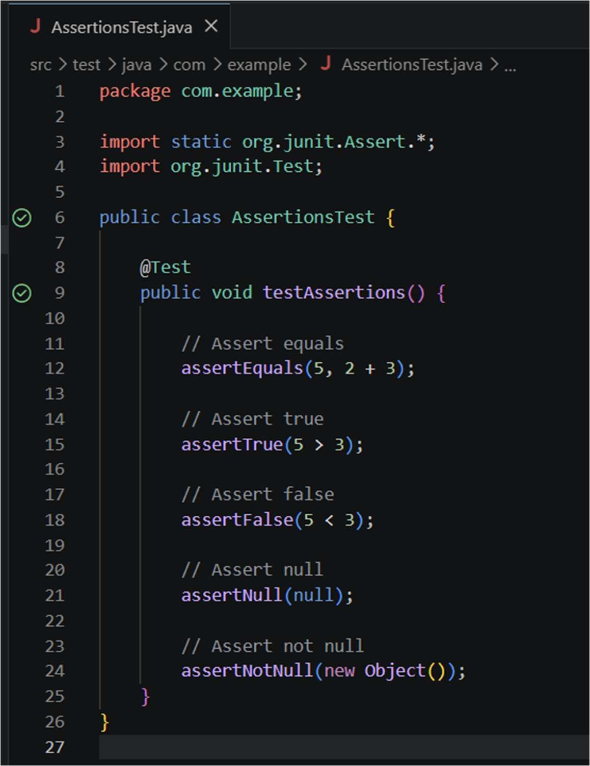
OUTPUT:
